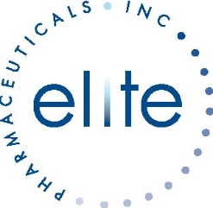
POSITION: Analytical Method Development Specialist

Key Responsibilities:
- Participate in Method development and validation to include testing, protocol and report writing
- Review data for compliance to specifications; document and investigate nonconformities
- Perform Routine Commercial Product Release and Stability Testing
- Lead investigations, and/or provide expertise for resolution of laboratory deviations and OOS/OOT results related to reagents and consumables
- Ensure Good Documentation Practices for relevant QC testing procedures, and that documents are current and accurately and clearly describe processes, reagents, and acceptance criteria

Qualifications:
- BS/MS in Chemistry, or closely related scientific discipline
- Proficient in Empower
- 8-10 years relevant quality control experience
- Strong working knowledge of ICH, cGMP, FDA and USP guidance
- Recent experience with method development, qualification/validation and transfer preferred
- Laboratory experience with a variety of analytical techniques including, but not limited to, GC,UV,HPLC, IR
- Proficient in general and non-routine laboratory skills
- Excellent computer, documentation, communication and organizational skills required
- Must have strong attention to detail, strong problem-solving skills, as well as the ability to work in a cross-functional team environment
- Exercises judgment within well-defined and established procedures and practices to determine appropriate action
- Strong interpersonal and verbal/written communication skills required
- Able to respond quickly to shifting priorities and to meet deadlines

Located in Bergen County, Northvale, New Jersey. We offer a competitive salary and benefits package.

